# **Condensed** **Game Design**

# 

# **Abyssal Legacy**

Secrets of the abyss

# 

Version #01

All work Copyright © 2018 by Centennial College.

All rights reserved.

# by: yueyang sun

## 

**Condensed** **Game Design** 1

**Game Overview** 2

**Gameplay Mechanics** 3

**Interface Sketch** 5

Timeline mission tree / commander perk tree 5

**Game World/ Level** 5

**Progression** 5

**Characters / Abilities** 6

**Non-player Characters** 6

**Bonuses** 6

**Story Index** 6

**Design Notes** 6

**Future Features** 6

## 

(For this document I’ll be cutting out the information that’s already in the other documents and the skipping the categories that’s the same as base game. Also, normally a starcraft story DLC would include a lot more missions, but for the purpose of the mid term, i’ll be only talking about one mission and one commander that’s part of the DLC)

## **Game Overview**

Abyssal Legacy is a new StarCraft 2 single player campaign mission pack. It introduces a new Zerg colony star system. A war wages out between the newly found Zerg planets and Protoss. A new mission system is added, a new map and a commander with a very unique playstyle is added to the game. The player will play from the Zerg factions perspective and have to complete a list of mission (yep, just one mission) in order to complete it.

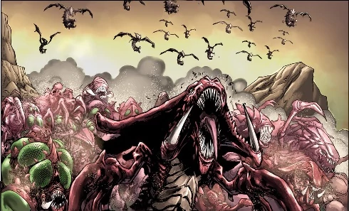

## **Gameplay Mechanics**

**Campaign:**

There are different Zerg missions that happens at the same time on the timeline. The player can only select one mission per row the timeline (except top row).

Mission completion:

Very top row - commander introduction, must play if the player wants to unlock that commander

Top few mission - commander specific missions

middle missions - pick one of the commander from choice to play

Last mission - can use all commanders the player unlocked

Commander perks are unlocked after completing a mission with them

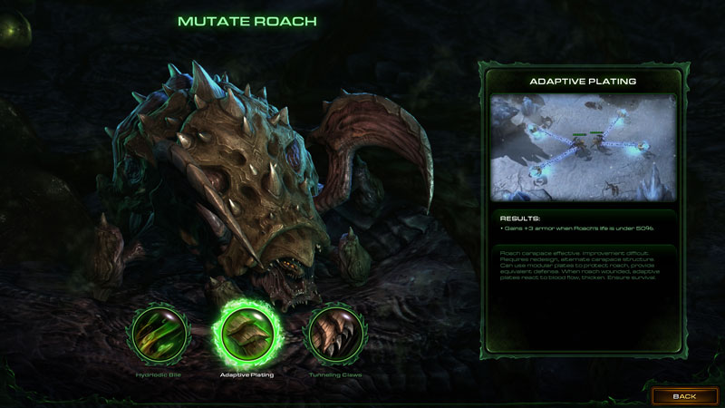

**Perk points:**

Each commander has their own perk tree. The player can only select one commander to play on the timeline per row. Upon completion, the player will then be prompted to use the perk point on an upgrade in the corresponding row from the commander’s perk tree.

So for example, if the timeline row is 4. There are 2 missions to select from, each with 2 unique commanders. And on the perk trees of each commander, there are 2 options in the 4th row. Then that means the player gets to obtain 1 of the 8 possible perks for that row, based on the mission selection, commander selection, and perk selection.

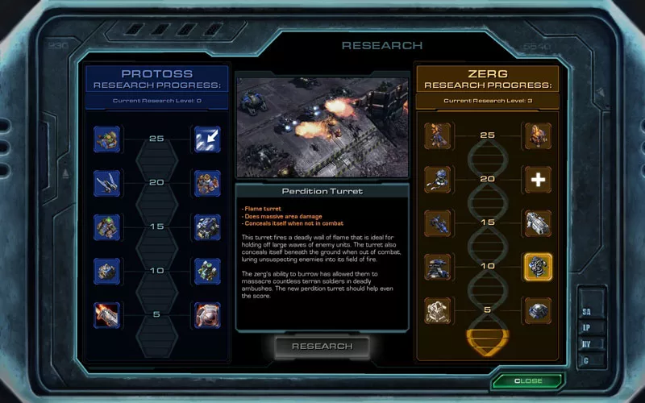

**Mission/Map:**

A new king of the hill map for the new Deskorra commander. The map is designed to scale up the difficulty over time. It doesn’t give the player start location mines, which encourages speed runs, or be mobile with the location of the base. The main goal is to offers a stage for the player to really play around with the new commander’s playstyle. See more in level design document

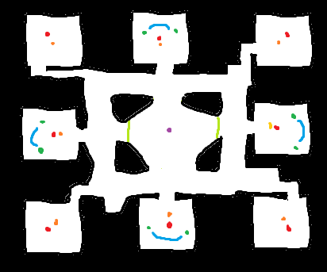

**Commander:** (small part of the DLC, but the main focus of my mid-term)

The biggest difference between co-op and story mode is how unique the commander playstyles are. Story mode have always been more interesting in background story but co-op provides more interesting, off-meta gameplay. Deskorra is a new commander that aims to combine the two.

The playstyle is very hero focused. The three heroes (Dostra, Nashanir and Elokia) under Deskorra each have a very distinct roles instead of the usual one-man army style of hero units.  
The base is also highly mobile, allowing for more dynamic playstyle. See more in character design document.

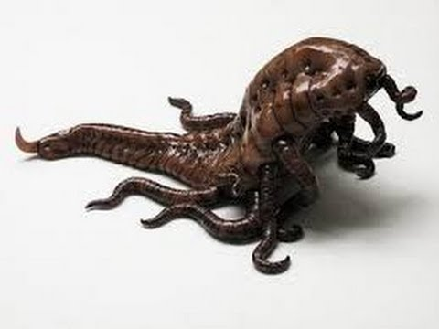

## **Interface Sketch**

## Timeline mission tree / commander perk tree

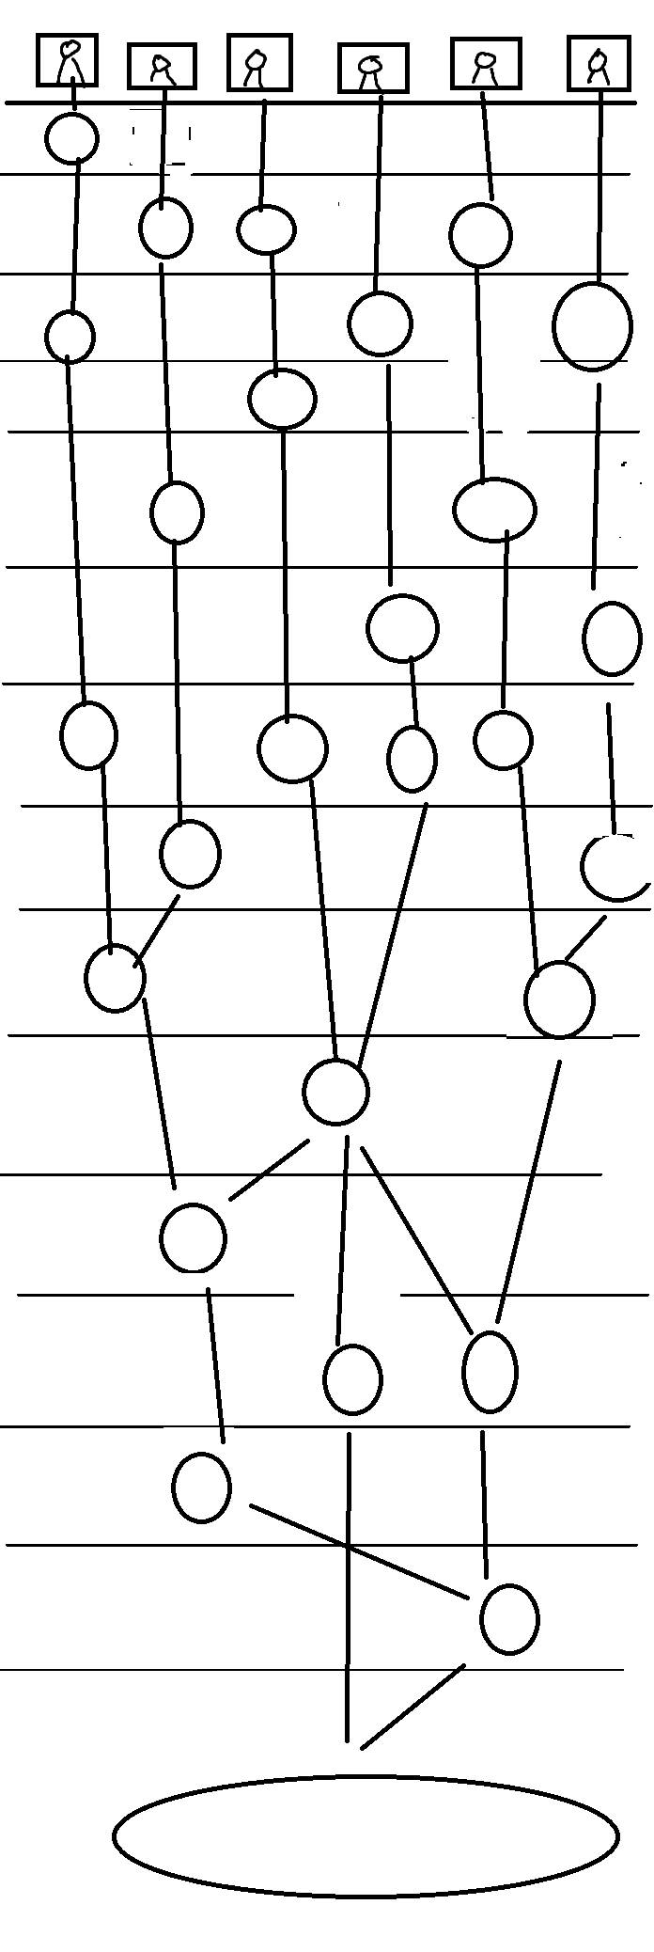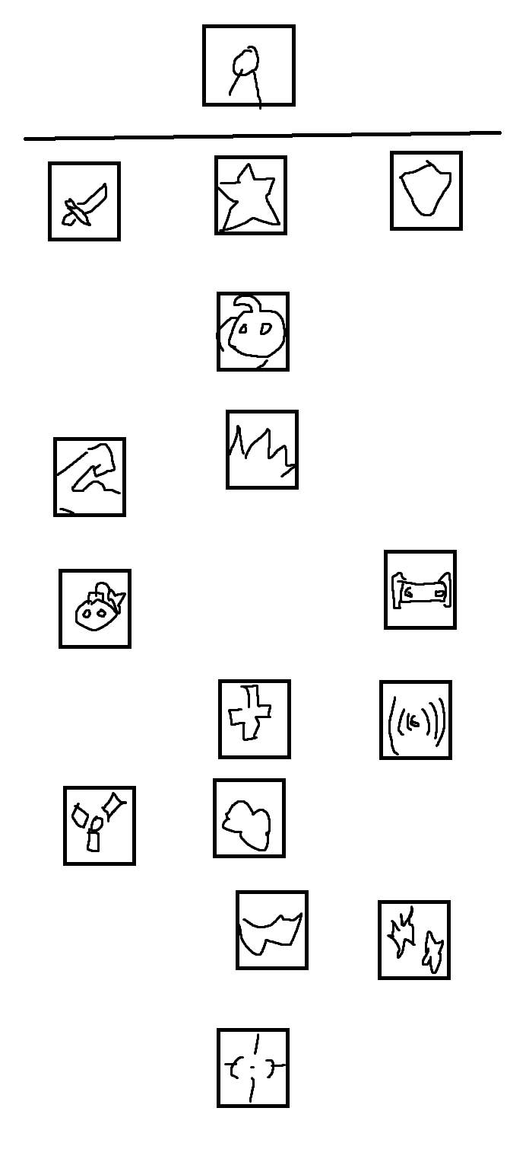

## **Game World/ Level**

See game world/ level documents

## **Progression**

Complete mission from the storyline. Other that the top row missions, only one mission per row can be completed before the player moves onto the next row. If the player doesn’t like the perk they received, they can go back and complete a different mission. This is grant them a perk point for the commander they just played, but will also erase the perk point they have used previously for that row.

## **Characters / Abilities**

see character documents

## **Non-player Characters**

All other commanders that’s not part of this DLC from StarCraft 2

## **Bonuses**

Unlock achievements

## **Story Index**

see game world documents

## **Future Features**

Rest of the missions/maps

Rest of the commanders

Story for the rest of the mission

Perk trees